Guidance for Topic 1 DQ 1
- First, make sure to enter your name in H2.
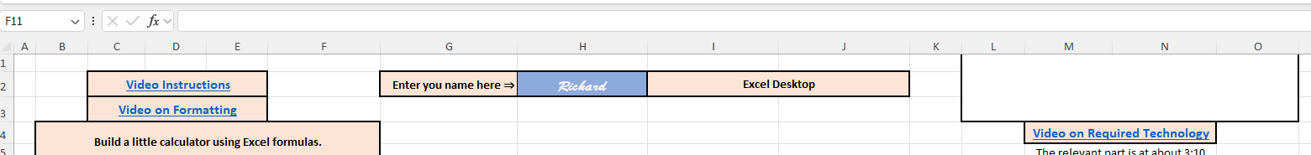
Also, watch the provided videos; they walk you through what needs to be done. In addition, make sure you are using Excel, for example, if you are using Google Sheets, you will see:

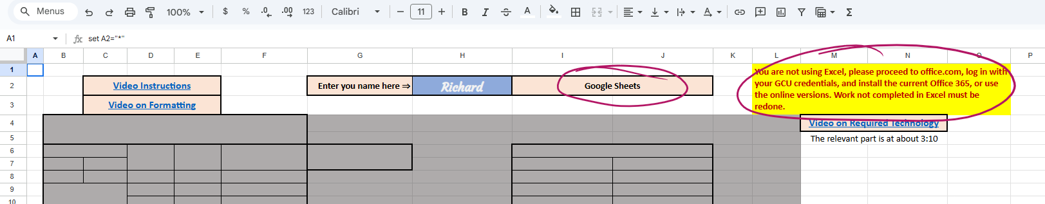

Clearly, you should not continue working as is; you need to use Excel!

- Make sure to watch the video, and the next step is to enter the numbers in B8 and C8 and enter a formula in F8. Pay attention to the feedback that the sheet indicates:
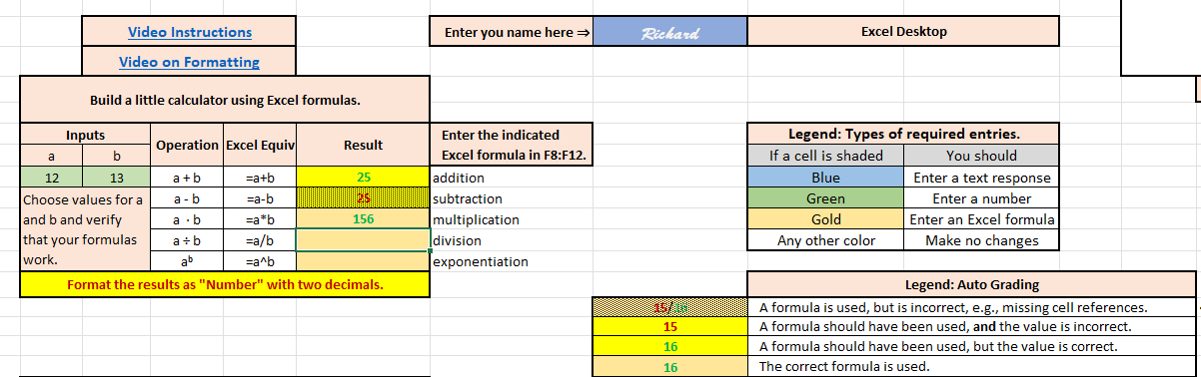
To see how the errors match up with the formulas (or not), here are the formulas: (Use CTRL-` to get this view):
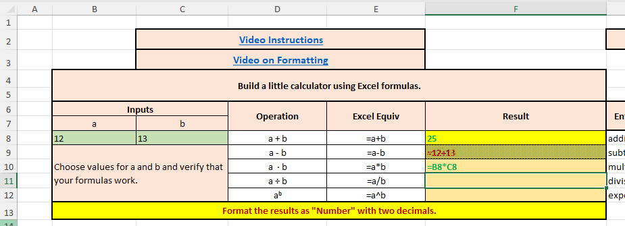

You can see here that in cell F8, just a number is entered, and that is incorrect; a formula with correct cell references must be used. (See the video for an explanation.) In F9, a formula is used, but not cell references. (Again, the importance of using cell references is discussed in the video.) F10 is just right! A correct formula with cell references for a and b is used.
- Next, highlight the answers and right-click them and format as “Number.” The default for the Number format is two decimal places. You can modify this by adding and subtracting decimal places; do not round, just format as requested. Before you format, you will see:

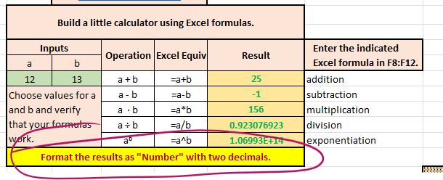
After formatting, you should see:
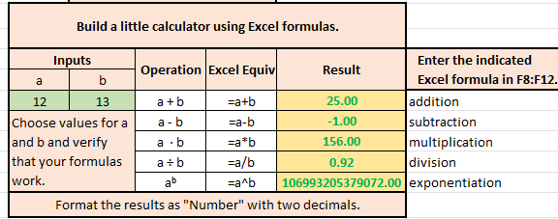
Note: You might need to enter something in a cell and hit “Enter” before the formatting error message goes away. Closing and reopening the sheet also works.

Also, F12 might overflow the cell, and you will see “#####”. In this case, you might choose to use “Scientific” instead of “Number” for F12. A video on formatting is included.
You can find many resources to help with Excel on YouTube, but you should have all that you need from our resources, and any additional things you want to learn about Excel are great, but be careful to use the techniques we are teaching for the work in this class.

- Enter any numbers from E21 to E28 and practice entering Excel formulas from H21 to H23. Make sure to format the cells, as explained above, to set the number of decimals as indicated for each item. Note the formula in H21 should be =AVERAGE(E21:E28). (This differs from the image)

